Ideation Phase
Define the Problem Statements

Date | 18 February 2026
Team ID | LTVIP2026TMIDS79720
Project Name | Advancing Nutrition Science through Geminiai
Maximum Marks | 2 Marks

Customer Problem Statement Template:
Create a problem statement to understand your customer's point of view. The Customer Problem Statement template helps you focus on what matters to create experiences people will love.
A well-articulated customer problem statement allows you and your team to find the ideal solution for the challenges your customers face. Throughout the process, you’ll also be able to empathize with your customers, which helps you better understand how they perceive your product or service.


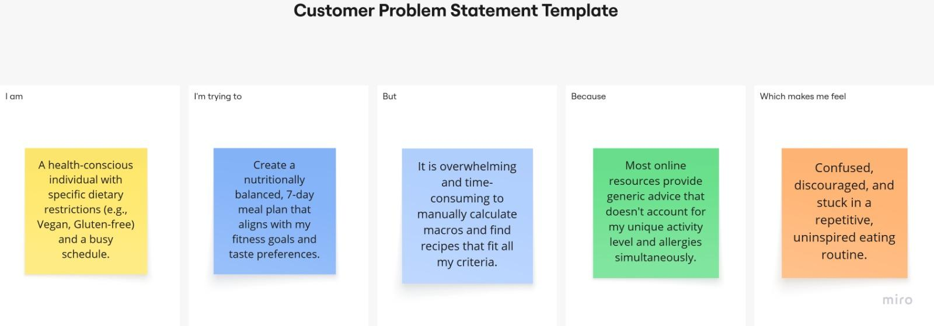

Problem Statement (PS) | I am (Customer) | I’m trying to | But | Because | Which makes me feel
PS-1 | A health-conscious individual with specific dietary restrictions (e.g., Vegan, Gluten-free) and a busy schedule. | Create a nutritionally balanced, 7-day meal plan that aligns with my fitness goals and taste preferences. | It is overwhelming and time-consuming to manually calculate macros and find recipes that fit all my criteria. | Most online resources provide generic advice that doesn't account for my unique activity level and allergies simultaneously. | Confused, discouraged, and stuck in a repetitive, uninspired eating routine.
PS-2 | Someone trying to track their daily intake or improve their eating habits through better awareness. | Quickly understand the calorie count, macronutrients, and health benefits of the specific foods I eat daily. | Traditional tracking apps require tedious manual entry or searching through massive, inaccurate databases.. | I need instant, expert-level "Health Verdicts" and nutrient breakdowns for complex or weighed portions without the hassle. | Anxious about whether I'm actually meeting my nutritional needs or unknowingly eating unhealthy foods.
PS–3 | A health-conscious individual who often encounters conflicting nutrition advice online or has specific questions about sustainable lifestyle changes. | Get immediate, scientifically-backed, and supportive answers to my specific nutrition questions, such as how to increase protein intake or manage energy levels. | Professional nutritionists are expensive and often unavailable for quick, day-to-day questions or "on-the-fly" coaching. | Most health apps provide static data (calories/steps) but lack a conversational "coach" interface that offers personalized, encouraging guidance | Uncertain about my choices, overwhelmed by misinformation, and unsupported in my long-term health journey

